TECHPORCH INCORPORATED

DragON — Password Update Guide
What to do after changing your Windows password
Version 2.0 | April 2026

Introduction
If you change your Windows password after you have already enrolled in DragON, you will need to update your stored password in DragON the next time you log in. This is a normal, expected process — not an error.
This guide walks you through the password update process step by step, so you can get back to work quickly and with confidence.

When Does This Happen?
The DragON password update process is triggered when all of the following conditions are true:
- You previously enrolled in DragON using your Windows credentials (username and password).
- You later changed your Windows password through one of the following methods:
  - Ctrl + Alt + Delete → "Change a password"
  - Through your IT department or Active Directory
  - Via Windows Settings → Accounts → Sign-in options
- You then attempt to log in to Windows using DragON as your credential provider.
Because DragON still has your old password stored, Windows will report a login failure. DragON will then guide you through updating your stored password — no re-enrollment required.

Step-by-Step Process

Step 1: Log in using DragON as usual
At the Windows login screen, follow your normal DragON login process:
- Select DragON as your credential provider on the Windows login screen.
- Select your enrolled theme.
- Perform your drag sequences in the correct order (drag from the Start Tile to the End Tile for each sequence).
DragON will authenticate your graphical credentials successfully. At this point, your drag sequences are verified — the issue is only with the stored Windows password.

Step 2: Windows reports a login failure
After DragON validates your drag sequences, it will attempt to log you in to Windows using the stored (old) password. Because your Windows password has changed, Windows will display the following error message:
"The user name or password is incorrect."
This is expected. Click OK to proceed.
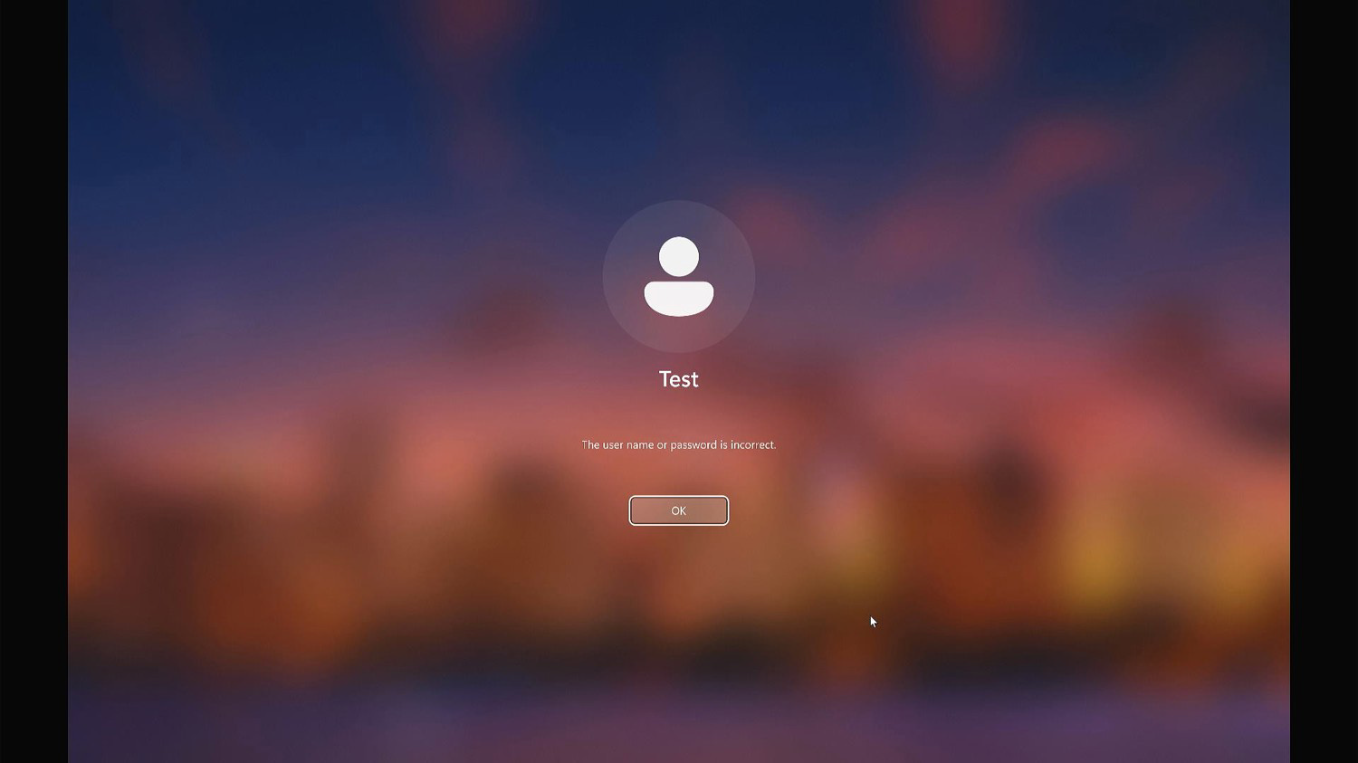
Figure 1: Windows displays this error because the stored password no longer matches your current Windows password.

Step 3: DragON prompts for your new password
After you click OK, DragON will display a password update screen with the following message:
"Your password has been changed. Please provide your new password and validate your identity by dragging Start Tile to End Tile."
On this screen:
- Enter your new Windows password in the "New Password" field.
- Re-enter your new Windows password in the "Reenter New Password" field.
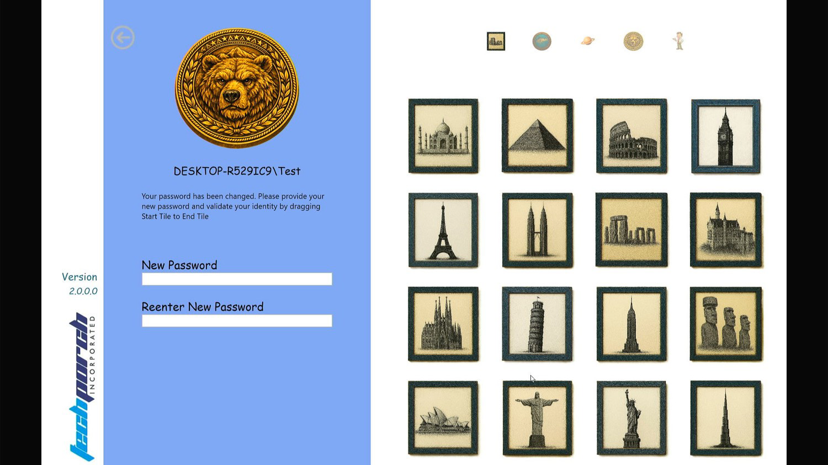
Figure 2: DragON prompts you to enter your new password and re-validate your identity.

Step 4: Re-validate your identity
After entering your new password in both fields, perform your drag sequences again in the correct order. This step confirms both your new password and your graphical authentication in a single action.

Step 5: Login completes
Once validation succeeds, DragON updates your stored credentials and Windows logs you in with the new password. Future logins will use the updated password seamlessly — no further action is required on your part.

Important Notes

No Re-Enrollment Required
You do not need to re-enroll in DragON. Your drag sequences — including your theme, tiles, and sequence order — remain unchanged. Only the stored Windows password is updated during this process.

❗ Forgot Your Drag Sequences?
If you forget your drag sequences during this process, click the Back-Arrow icon (located in the top-left corner of the DragON screen) to return to the standard Windows login screen. From there, you can log in using your new Windows password or PIN directly.

Trial Version Users
If you are using the trial version of DragON, please note that you are limited to a single drag sequence. The password update process works the same way — simply perform your one drag sequence when prompted to re-validate.

Troubleshooting
If you encounter issues during the password update process, refer to the table below for common problems and solutions.

Issue | Solution
"The user name or password is incorrect" keeps appearing | Make sure you are entering your new Windows password (not the old one) in the DragON password update screen. Both the "New Password" and "Reenter New Password" fields must match your current Windows password exactly.
Forgot your drag sequence | Click the Back-Arrow icon (top-left of the DragON screen) to return to the standard Windows login screen. Use your Windows password or PIN to log in. Contact your system administrator to reset your DragON enrollment if needed.
DragON does not prompt for new password | Ensure that DragON is selected as the active credential provider on the Windows login screen. If another credential provider is selected, click the sign-in options and choose DragON.

Need Help?
If you continue to experience difficulties with the password update process, the following resources are available to you:
- Contact your system administrator to reset your DragON enrollment or troubleshoot credential issues.
- Use the Back-Arrow icon on the DragON login screen to fall back to standard Windows authentication at any time.
- Visit www.techporch.com for additional product documentation, FAQs, and support resources.

DragON Password Update Guide — Version 2.0
© 2026 Techporch Incorporated. All rights reserved.
www.techporch.com

